**Design database for Zen class programme**

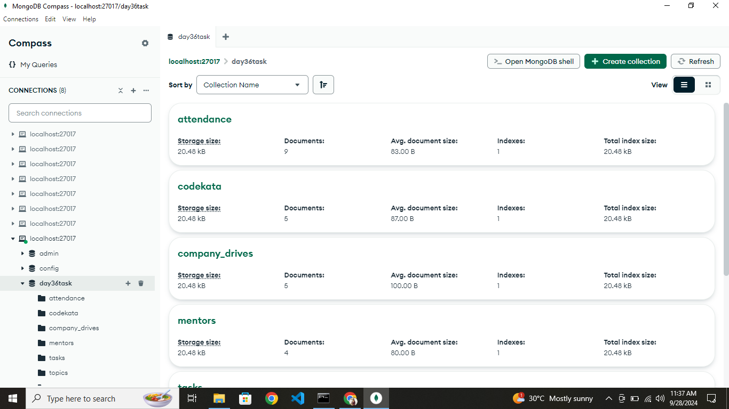

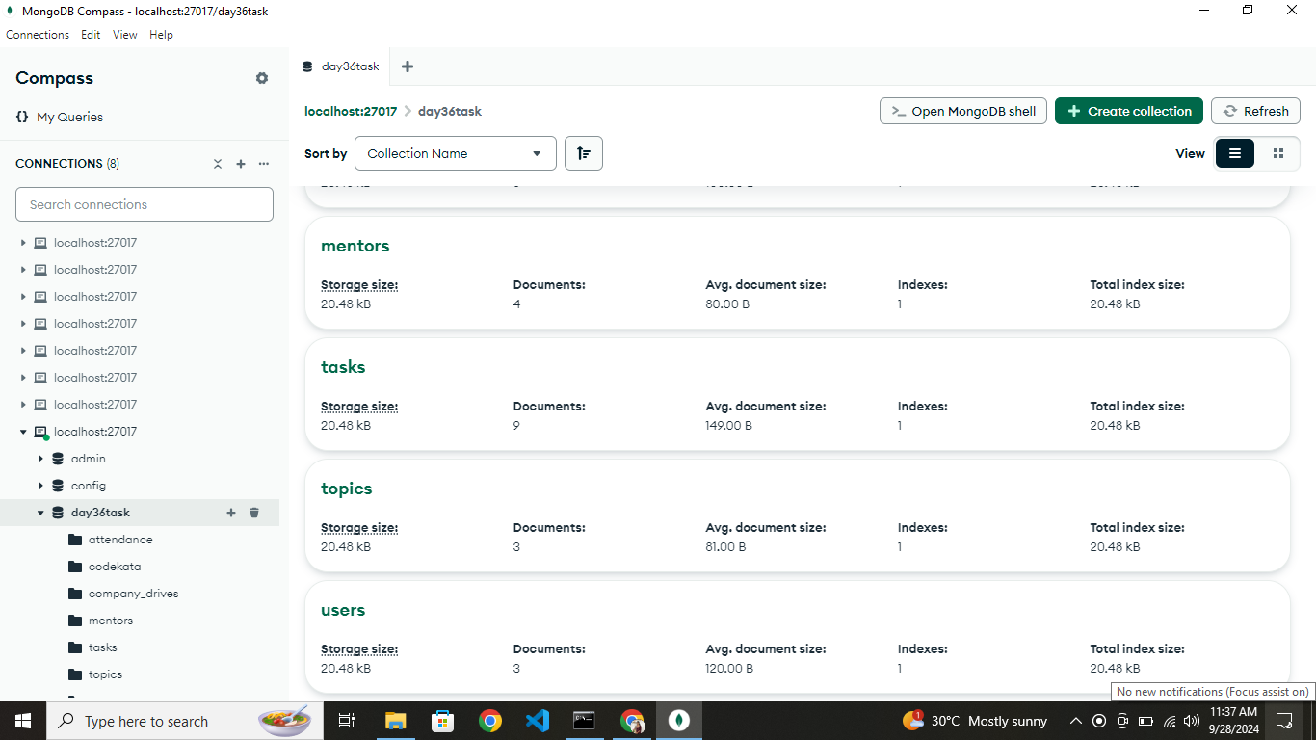

1. Find all the topics and tasks which are thought in the month of October

**db.createView( "octoberSession", "topics", [**

**{**

**$lookup:**

**{**

**from: "tasks",**

**localField: "topic_id",**

**foreignField: "topic_id",**

**as: "tasksDocs"**

**}**

**},**

**{**

**$project:**

**{**

**_id: 0,**

**topic_id:1,**

**task_id:"$tasksDocs.task_id",**

**Date:1,**

**topic_name:1,**

**task_name:"$tasksDocs.task_name"**

**}**

**},**

**{ $unwind: "$task_id" },**

**{ $unwind: "$task_name" }**

**] )**

**db.octoberSession.aggregate([{$match:{$expr:{$eq:[{$month:{$dateFromString:{dateString:"$Date", format:"%Y-%m-%d"}}},10]}}}])**

1. Find all the company drives which appeared between 15 oct-2020 and 31-oct-2020

Ans: db.company_drives.find({Date:{$gte:"2020-10-15",$lte:"2020-10-31"}})

1. Find all the company drives and students who are appeared for the placement.

Ans: db.createView( "placement1", "company_drives", [

{

$lookup:

{

from: "users",

localField: "User_id",

foreignField: "User_id",

as: "userDocs"

}

},

{

$project:

{

_id: 0,

User_id: 1,

User_name:"$userDocs.Name",

drive_id: 1,

Date: 1,

drive_name:1,

}

},

{ $unwind:"$User_name" }

] )

db.placement1.find()

1. Find the number of problems solved by the user in codekata

Ans: db.codekata.aggregate( [

{

$group:

{

_id: "$User_id",

totalProblemsSolved: { $sum: {$toInt:"$Problems_solved" }}

}

}

] )

1. Find all the mentors with who has the mentee's count more than 15

Ans: db.mentors.find({ mentee_count: { $gt: 15 } }).pretty()

1. Find the number of users who are absent and task is not submitted between 15 oct-2020 and 31-oct-2020

Ans: db.attendance.aggregate([

{

$match:{

Date:{

$gte:"2020-10-15", $lte:"2020-10-31"

},

Status:"Absent"

}

},

{

$lookup:{

from :"tasks",

localField:"User_id",

foreignField:"User_id",

as:"tasksDocs"

}

},

{

$match:{

"tasksDocs.submitted":"false"

}

},

{

$group:{

_id:null,

count:{$sum:1}

}

}

])

|  |
| --- |
|  |